AN1292 Demonstration ReadMe for the  
dsPICDEM™ MCHV-2 Development Board or dsPICDEM™ MCHV-3 Development Board with the dsPIC33CH512MP508 Motor Control PIM (MPLAB® X IDE)

1. Introduction

This document describes the setup requirements for running the Sensor-less FOC algorithm with a PLL Estimator, which is referenced in AN1292 “*Sensorless Field Oriented Control (FOC) for a* *Permanent Magnet Synchronous Motor (PMSM) Using a PLL Estimator and Field Weakening (FW)”.*

The demonstration is configured to run on either the dsPICDEM™ MCHV-2 Development Board or the dsPICDEM™ MCHV-3 Development Board in the External Op-amp configuration with the dsPIC33CH512MP508 Motor Control Plug-In Module(PIM).

1. Suggested Demonstration Requirements
   1. Motor Control Application Firmware Required for the Demonstration

* AN1292_dsPIC33CH512MP508_EXT_OPAMP_MCLV2_MCHV2_MCHV3.zip

**Note:**

In this document, hereinafter this firmware package is referred as firmware**.**

* 1. Software Tools Used for Testing the firmware
* MPLAB X IDE v5.10
* MPLAB® XC16 Compiler v1.36b
* MPLAB X IDE Plugin: Data Monitor and Control Interface (DMCI) v2.71

**Note:**

The software used for testing the firmware prior to release is listed above. It is recommended to use the version listed above or later versions for building the firmware.

* 1. Hardware Tools Required for the Demonstration

To set up the demonstration, you may use one of the High-Voltage Motor Control Development Boards mentioned below:

* dsPICDEM™ MCHV-2 Development Board (DM330023-2) or
* dsPICDEM™ MCHV-3 Development Board (DM330023-3)

**Note:**

In this document, hereinafter High-Voltage Motor Control Development Board selected for setting up the demonstration is referred as Development Board**.**

* High Voltage 3-Phase Permanent Magnet Synchronous Motor (AC300025)
* dsPIC33CH512MP508 Motor Control Plug-in module (MA330045)

**Note:**

The All items listed under the section 2.3 Hardware Tools Required for the Demonstration are available at microchip DIRECT.

1. Hardware Setup

This section describes hardware setup required for the demonstration. Motor phase current feedbacks needed by the firmware are amplified by the operational amplifiers provided on the Development Board. This is referred as ‘*external amplifier configuration*’.

Refer *dsPICDEM™ MCHV-2 Development Board User’s Guide or dsPICDEM™ MCHV-3 Development Board User’s Guide*, for any clarification while setting up the hardware.

1. ***Before making any connection, verify that the Development Board is not powered and it is fully discharged. This can be done by checking if Power on Status LED D13(Red) is off.***
2. Open the top cover of the enclosure and set up the following jumpers (if they are not in specified positions):

|  |  |  |  |
| --- | --- | --- | --- |
| **Jumper** | **Pins to Short** | **Board Reference** | **Remarks** |
| J11 | 3-4 |  | These Jumpers are present on the Development Board.*These can be accessed only after opening the top cover of the enclosure.* |
| J12 | 1-2 |
| J13 | 1-2 |
| J14 | 1-2 |
| PWM OUTPUTS | ENABLE  position |  | These Jumpers can be accessed without opening the enclosure, from the front side of the board(or enclosure). |
| USB | FOR USB position |  |

1. Connect the three phase wires from the motor to M1, M2, and M3 terminals of connector J17(there is no specific order), provided on the Development Board.



1. Connect the ‘External Op Amp Configuration Matrix board’ to matrix board header J4. Ensure the matrix board is correctly oriented before proceeding.

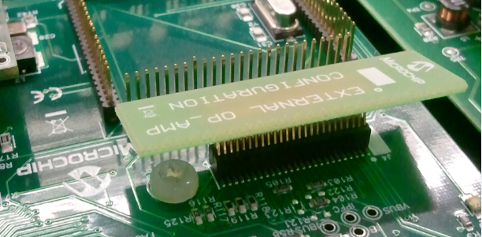

1. Insert the dsPIC33CH512MP508 Motor Control PIM into the PIM Socket U11 provided on the Development Board. Make sure the PIM is correctly placed and oriented before proceeding.
2. Close the top cover of the enclosure and secure it with screws.
3. Power Cord Connection. Make sure the power cord is disconnected from the AC mains before connecting the female terminal of the power cable to the AC input connector J1 of the Development Board.



1. To program the device, a mini-USB connection is required between Host PC and the Development Board. Connect a mini-USB cable from your computer to the mini-USB connector “PROGRAM/DEBUG” of the Development Board. The development board features a Built-in isolated Programmer or Debugguer (Microchip Starter Kit).

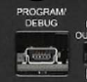

1. Power up the Development Board by connecting power cord to the mains. To verify the unit is powered, make sure LEDs D6, D13, D16 and D18 are ON.
2. Software Setup and Run
   1. Setup: MPLAB X IDE and MPLAB XC16 Compiler

Install MPLAB X IDE and MPLAB XC16 Compiler versions that support the device dsPIC33CH512MP508 assembled on the Plug-in Module(PIM). The version of the MPLAB X IDE, MPLAB XC16 Compiler and DMCI plug-in used for testing the firmware are mentioned in the section Motor Control Application Firmware Required for the Demonstration. To get help on

* MPLAB X IDE installation, refer [link](http://microchipdeveloper.com/mplabx:installation)
* MPLAB XC16 Compiler installation steps, refer [link](http://microchipdeveloper.com/xc16:installation)

If MPLAB IDE v8 or earlier is already installed on your computer, then run the MPLAB driver switcher (It is installed when MPLAB X IDE is installed) to switch from MPLAB IDE v8 drivers to MPLAB X IDE drivers. If you have Windows 7 or 8, you must run MPLAB driver switcher in ‘Administrator Mode’. To run the Device Driver Switcher GUI application as administrator, right click on the executable (or desktop icon) and select ‘Run as Administrator’. For additional details refer MPLAB X IDE help topic *“Before You Begin: Install the USB Device Drivers (For Hardware Tools): USB Driver Installation for Windows Operating Systems”.*

* 1. Setup: Data Monitor and Control Interface (DMCI)

The Data Monitor and Control Interface (DMCI) is a MPLAB X IDE plugin that allows a developer to interact with an application while the application program is running. DMCI provides a graphical user interface which operates within the MPLAB X IDE enabling the developer to examine or modify the contents of application variables without having to halt the application during a debug session. For additional information on DMCI follow the [link](http://microchipdeveloper.com/mplabx:dmci). To use DMCI, the plugin must be installed:

* In MPLAB X IDE, select *Tools>Plugins* and click on the **Available Plugins** tab.
* Select DMCI plug-in by checking its check box, and then click **Install**.
* Look for your tool DMCI under *Tools>Embedded*. If you do not see it, you may need to

close and re-open MPLAB X IDE.

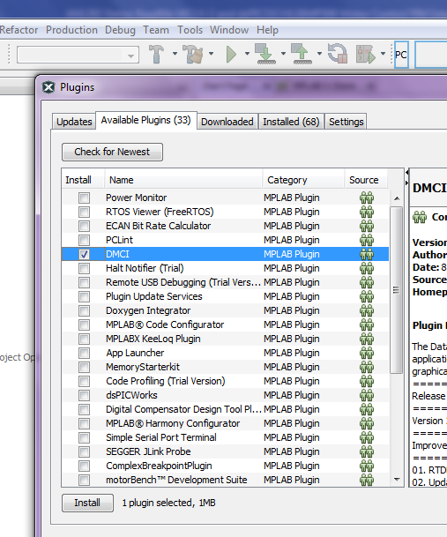

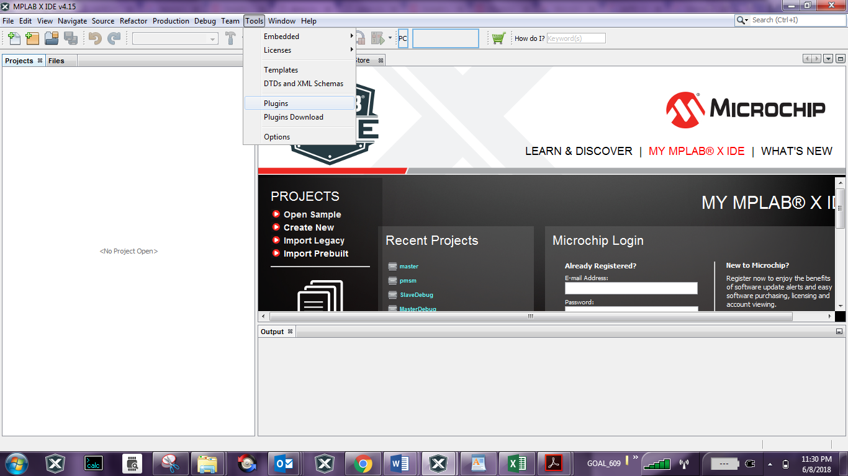

1. Basic Demonstration
   1. Firmware Description

The firmware version required for the demonstration is mentioned under the section Motor Control Application Firmware Required for the Demonstration.

This firmware is implemented to work on Microchip’s dual core 16-bit Digital signal controller (dsPIC® DSC) dsPIC33CH512MP508**.**There are two independent dsPIC DSC Cores called ‘Master Core’ and ‘Slave Core’ in the device. For more information, see the *dsPIC33CH512MP508 Family datasheet*.

In MPLAB X IDE, the code for two cores are developed as separate projects with following device selections.

* Device selection in Master Project (code for Master Core) is dsPIC33CH512MP508
* Device selection in Slave Project (code for Slave Core) is dsPIC33CH512MP508S1

Hence the firmware used in this demonstration consists of two MPLAB X projects *master.X* (referred as Master Project) and *pmsm.X*(referred as Slave Project).

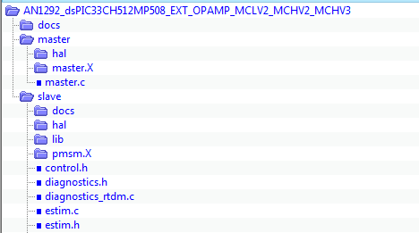The firmware directory structure is shown below:

**Slave Project** *pmsm.X* and associated files.

**Master Project** *master.X* and associated files.

**ReadMe Documents**

tuning_params_xxx.xls

**Note:**

The project may not build correctly in Windows OS if Maximum path length of any source file in the project is more than 260 characters. In case absolute path is exceeding or nearing maximum length, do any (or both) of the following:

* Shorten the name of the directory containing the firmware used in this demonstration. In this case, rename directoryAN1292_dsPIC33CH512MP508_EXT_OPAMP_MCLV2_MCHV2_MCHV3to more appropriate shorter name. In case you renamed the directory, consider the new name while reading instructions provided in the upcoming sections of the document.
* Place firmware in a location, such that absolute path length of each file included in the projects does not exceed the Maximum Path length specified.

For details, refer MPLAB X IDE help topic *“Path, File and Folder Name Restrictions”.*

Function of the Master Core (as defined in the Master Project *master.X*) is:

* To set device Configuration bits applicable for both Master and Slave cores (As Configuration bits for Master and Slave cores are available in Master core registers). Note that the I/O port ownership between Master Core and Slave Core is decided by the Configuration bits.
* Configure Master Core Oscillator Subsystem to generate clocks needed for the operation of Core and its peripherals. In the firmware Master is configured to operate at 90MHz.
* To program and enable the Slave core by invoking XC16 library (libpic30.h) routines _program_slave () and _start_slave ().

Function of the Slave Core (as defined in the Slave Project *pmsm.X*) is:

* To configure Slave Core Oscillator Subsystem to generate clocks needed for operation of Core and its peripherals. In the firmware, Slave core is configured to operate at 100MHz.
* To configure I/O ports and Slave Core peripherals (such as PWM Generators PG1, PG2, and PG3, ADC Cores, UART1) required for functioning of the firmware.
* To execute the Motor Control Demo Application based on the Microchip Application note AN1292.

Once Master Core programs and enables the Slave Core, it can autonomously run the Motor Control Demo application residing in its PRAM. The Motor Control Demo application uses push button to start or stop the motor and potentiometer to vary speed of the motor.

For more details refer Microchip Application note AN1292 *“Sensorless Field Oriented Control(FOC) for a Permanent Magnet Synchronous Motor(PMSM) using a PLL Estimator and Field Weakening(FW)”* available at [Microchip web site](http://www.microchip.com/)

* 1. Basic Demonstration

Follow below instructions step by step to setup and run the motor control demo application:

1. 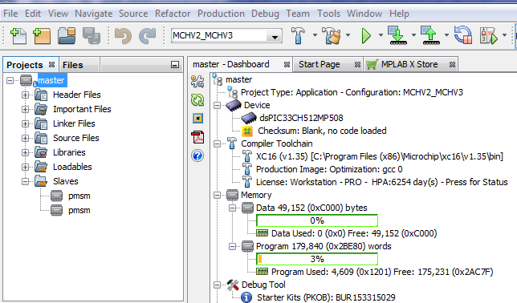Start MPLAB X IDE and open (*File>Open Project)* the Master Project *master.X*(..*\AN1292_dsPIC33CH512MP508_EXT_OPAMP_MCLV2_MCHV2_MCHV3\master\master.X*) with device selection *dsPIC33CH512MP508* (Master Core).

1. 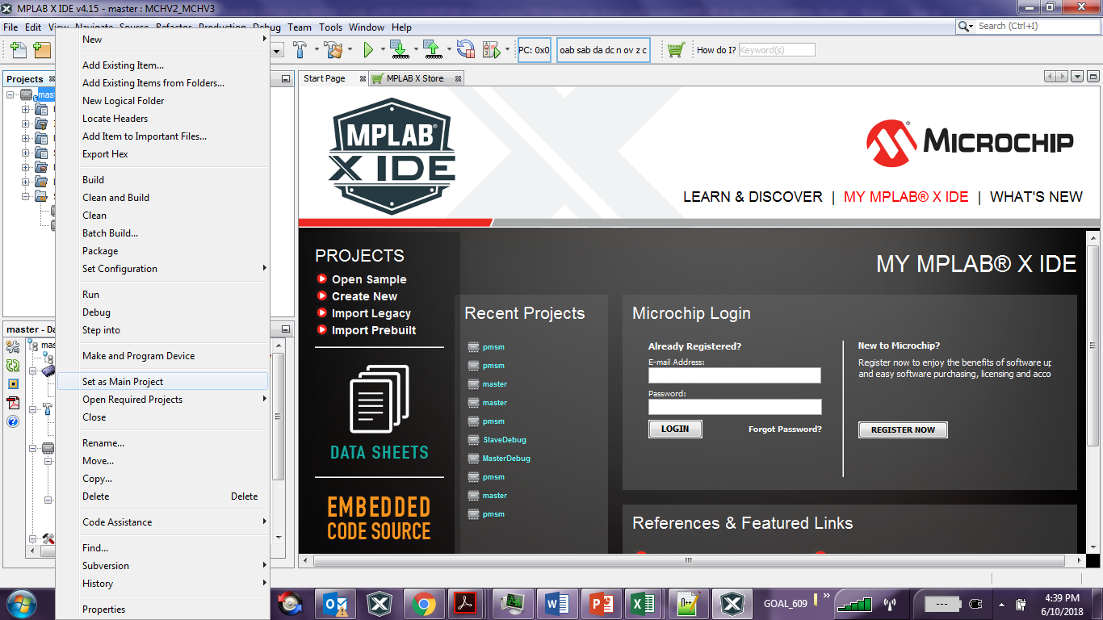Set the Master Project *master.X* as main project by right clicking the project name and selecting “Set as Main Project” as shown. The project “master” will then appear in **bold**.
2. 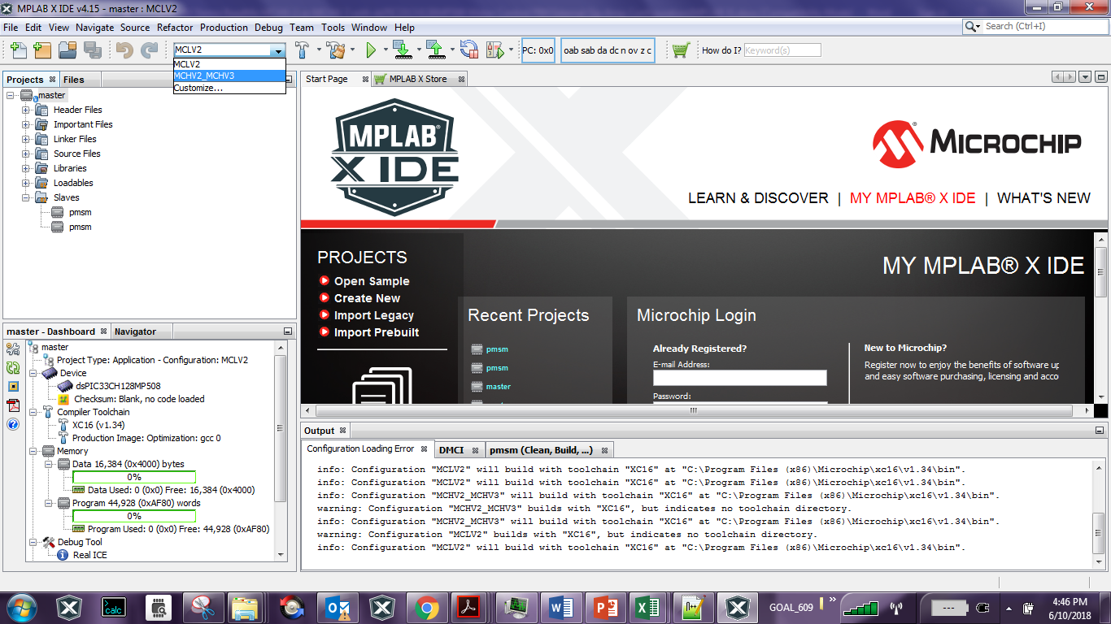Select project configuration as “MCHV2_MCHV3” from the Project Configuration drop down box on the toolbar as shown:

As shown in the figure above, there may be multiple project configurations available for *master.X*.

1. In the Projects window, right click on the Slaves folder of the project tree (of Master project *master.X)* and select “Properties”. This will open the “Slaves” category of Project Properties dialog.

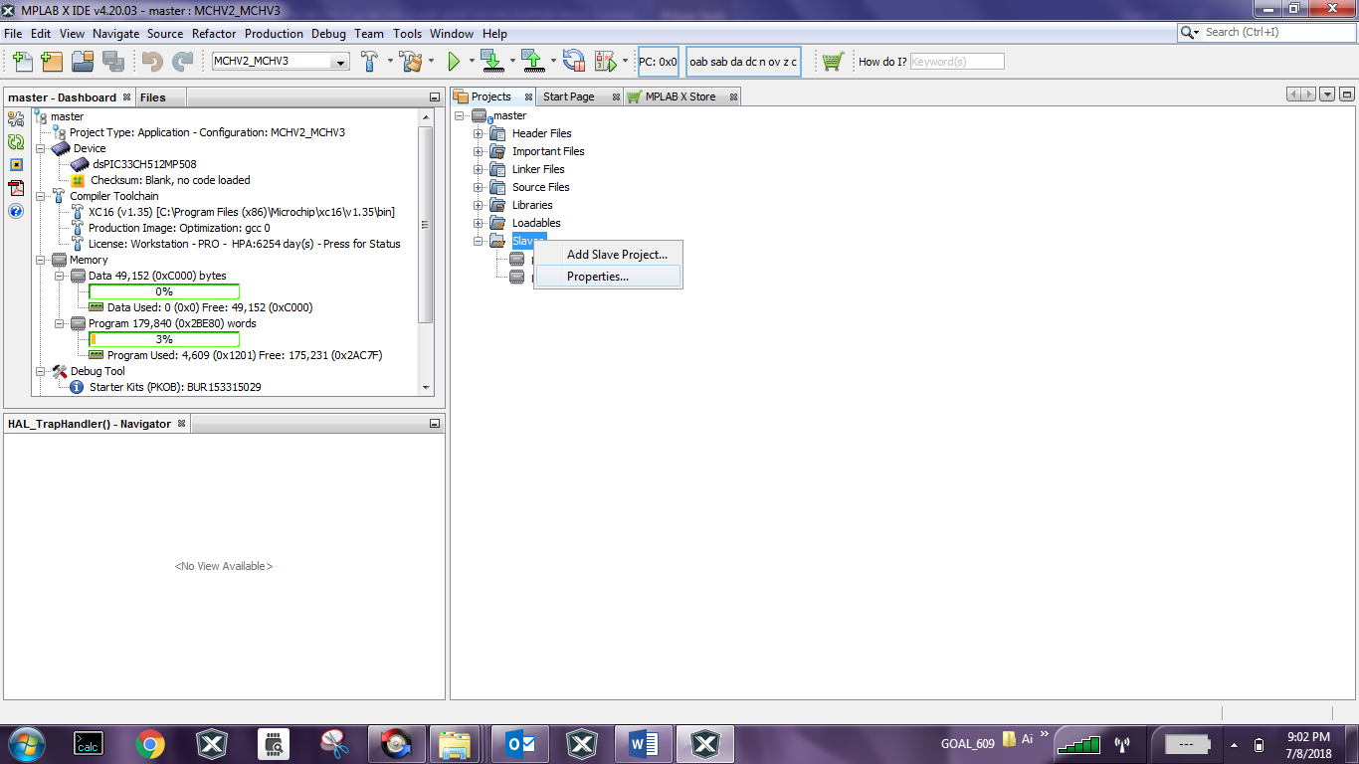Verify “Slaves” category of Project Properties dialog, and ensure details are as follows (see figure):

* Item is *pmsm.X*
* Configuration is *“MCHV2_MCHV3”*
* Image name is *“pmsm”* and
* Check box *“Build”* is checked
* 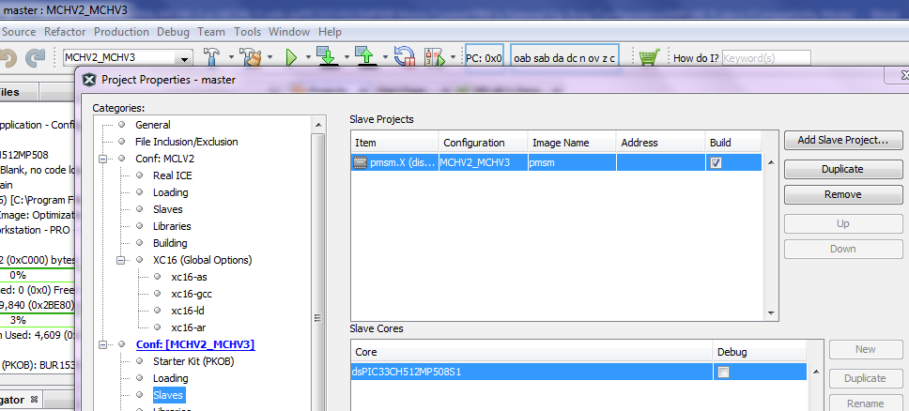Check box *“Debug”* is unchecked

**Note:**

You may encounter build error,

* If any of the values are not as mentioned above (or as shown figure below) or
* If the slave project *pmsm.X* is moved or deleted from the firmware directory (in this case ‘A1292_dsPIC33CH512MP508_EXT_OPAMP_MCLV2_MCHV2_MCHV3’

1. 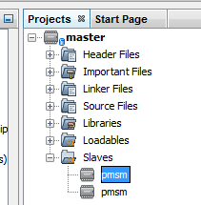In the Projects window, right click on the Slaves folder of the project tree (of Master project *master.X)* and select any one of the project “pmsm”. This will open the Slave project *pmsm.X* in MPLAB X IDE project window. Alternatively, you can open (*File>Open Project*) the Slave project from its current location like any other MPLAB X project.

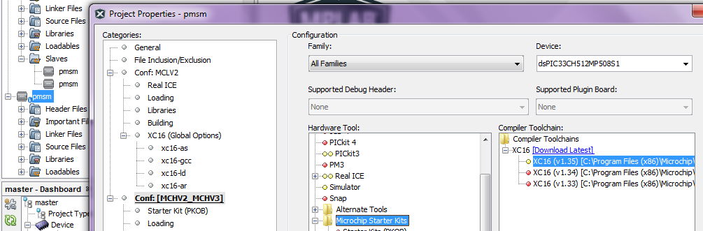The selected device in Slave project *pmsm.X* can be viewed by opening its Project Property Dialog. As can be seen from the below figure, in this firmware it is set as dsPIC33CH512MP508S1(as shown in figure below), which represents Slave core of thedsPIC33CH512MP508*.*

**Note:**

* There may be multiple project configurations like “MCLV2”, “MCHV2-MCHV3”, etc. available in both Master project *master.X* and Slave project *pmsm.X*.
* The project configuration “MCHV2_MCHV3” in the Master Project *master.X* is configured to associate with configuration “MCHV2_MCHV3” of Slave project *pmsm.X*.
* If multiple project configuration associations are defined between Master Project and Slave Project you will see as many slave projects listed under Slaves folder of the Master Project tree. In the above figure, you can see two “pmsm” projects, as two project configuration associations were defined between Master project *master.X* and Slave project *pmsm.X*

1. Unfold Header Files folder of Slave project tree and click open the header file userparms*.h* in Editor window. Verify header file userparms.h(included in the Slave project *pmsm.X*) to ensuremacro definitions TUNING, OPEN_LOOP_FUNCTIONING, and TORQUE_MODE is not defined.
2. Right click on the Master Project *master.X* and select “Properties” to open its Project Properties Dialog. Click the “Conf: [MCHV2_MCHV3]” category to reveal the general project configuration information.

In the *‘****Conf-MCHV2_MCHV3’*** category window:

* Select the specific Compiler Toolchain from the available list of compilers. Please ensure MPLAB® XC16 Compiler supports the device dsPIC33CH512MP508.In this case “XC16(v1.35)” is selected. The compiler used for testing the firmware is listed in the section 2.2 Software Tools Used for Testing the firmware.
* Select the Hardware Tool to be used for programming and debugging. In this case, “MCHV-SK” should be selected as the programmer from Microchip Starter Kits section of Hardware Tool.
* 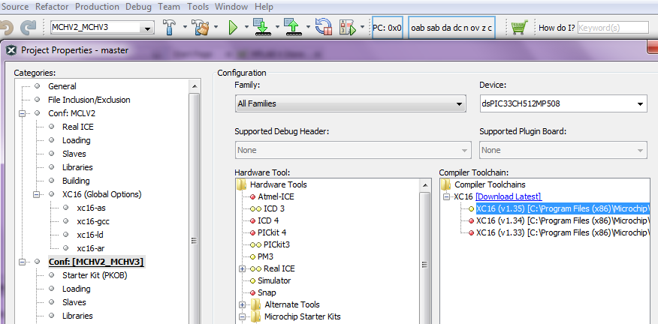After selecting Hardware Tool and Compiler Toolchain, click button **Apply.**

1. Right click on the associated Slave Project *pmsm.X* and select “Properties” to open its Project Properties Dialog. Click the “Conf: [MCHV2_MCHV3]” category to reveal the general project configuration information.

In the *‘****Conf-MCHV2_MCHV3’*** category window:

* Select the specific Compiler Toolchain from the available list of compilers. Please ensure MPLAB® XC16 Compiler supports the device dsPIC33CH512MP508S1.
* After selecting Compiler Toolchain, click button **Apply**.

This step is required, to build the Slave Project with a specific compiler version.

1. To build the Master Project (in this case *master.X*) and program the device dsPIC33CH512MP508, click “**Make and Program Device Main project**” on the toolbar. Upon this, MPLAB X IDE begin executing following activities in order:

* builds Slave Project *pmsm.X* (linked toMaster Project *master.X*)
* builds Master Project *master.X* and
* 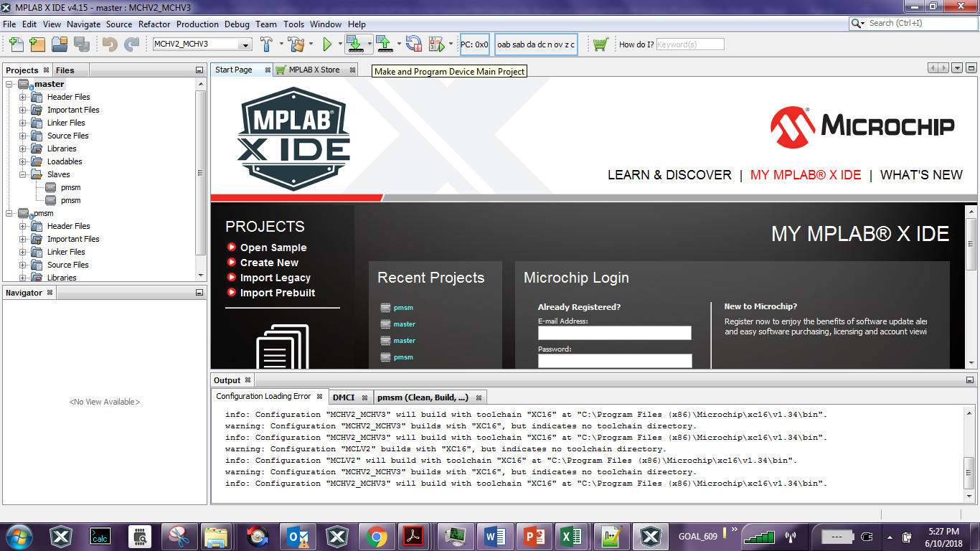Programs Master flash memory of dsPIC33CH512MP508 with code generated when building the Master Project and the Slave Project.

**Note:**

In this firmware configuration, the Master Core programs the Slave Core. When device is programmed, the Slave core image is placed in the Master flash. When the Master Core is powered on and begins execution of code, it transfers the Slave image from the Master flash to the Slave PRAM.

1. If the device is successfully programmed, **LED D2** will be turned ON. This indicates Slave Core is programmed and enabled by Master Core.
2. Run or Stop the motor by pressing the push button **S1**(labeled as **“PUSHBUTTON”**) in the front panel of the Board. The function of the pushbutton (Run/Stop of the motor) is indicated by turning ON or OFF **LED D19**.



1. If desired, the motor speed can be varied using the potentiometer (labeled **“POT**”).

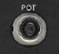

1. Press push button **S1**(labeled as **“PUSHBUTTON”** in the front panel of the Board) to stop the motor.

**Note:**

The macro definitions END_SPEED_RPM, NOMINAL_SPEED_RPM, and MAXIMUM_SPEED_RPM are specified in userparms.h file included in the Slave project *pmsm.X*. The definitions NOMINAL_SPEED_RPM, and MAXIMUM_SPEED_RPM are defined as per the specification provided by the Motor manufacturer. *Exceeding manufacture specification may lead to damage of the motor or(and) the board.*

* 1. Data visualization through DMCI Plug-in of MPLABX

The Slave Project of the firmware comes with the software library for Real Time Data Monitoring (RTDM), needed to interface with DMCI Plug-in available in the MPLAB X IDE. RTDM, along with DMCI creates a communication link between a host PC and a target device for debugging applications in real-time. For additional information on DMCI, click on the [link](http://microchipdeveloper.com/mplabx:dmci) .For additional information on RTDM click on the [link](http://www.microchip.com/development-tools/resources/real-time-data-monitoring-tool---rtdm).

1. 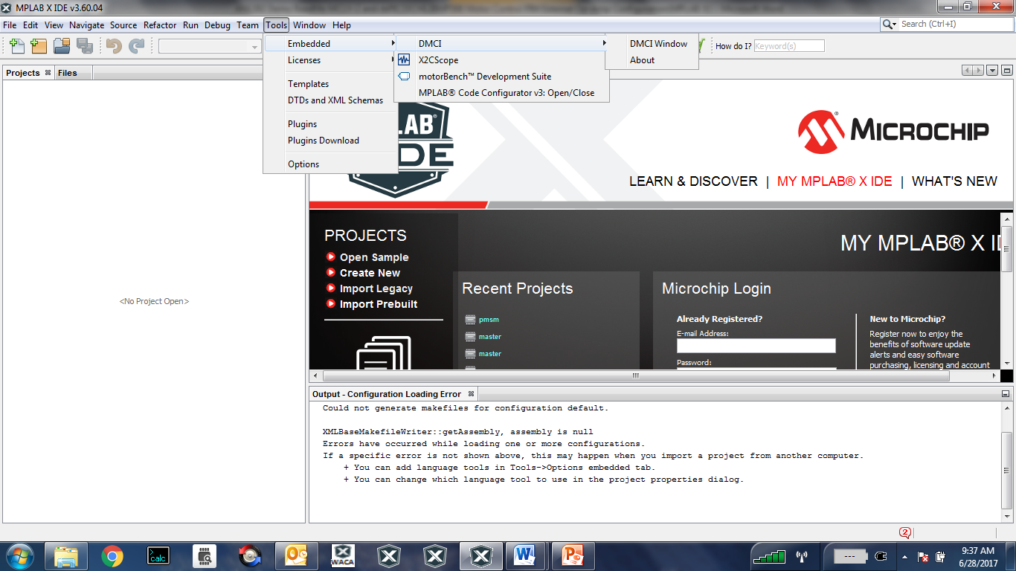Ensure DMCI Plug-in is installed. Look for DMCI under *Tools>Embedded*. If you do not see it, follow instructions provided in the section Setup: Data Monitor and Control Interface (DMCI) to install the plug-in.
2. 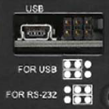To utilize RTDM communication for this demonstration, a USB connection is required between Host PC and the Development Board. Connect a mini-USB cable from your computer to the J6 connector (labeled as “USB” on the front panel of the board enclosure) of the Development Board.
3. Ensure application is configured and running as described under Section Basic Demonstration by following steps 1 through 13.
4. Set Slave project configuration. To do that right click on the Slave Project *pmsm.X* and set project configuration (*File>Set Configuration>MCHV2_MCHV3)* as shown

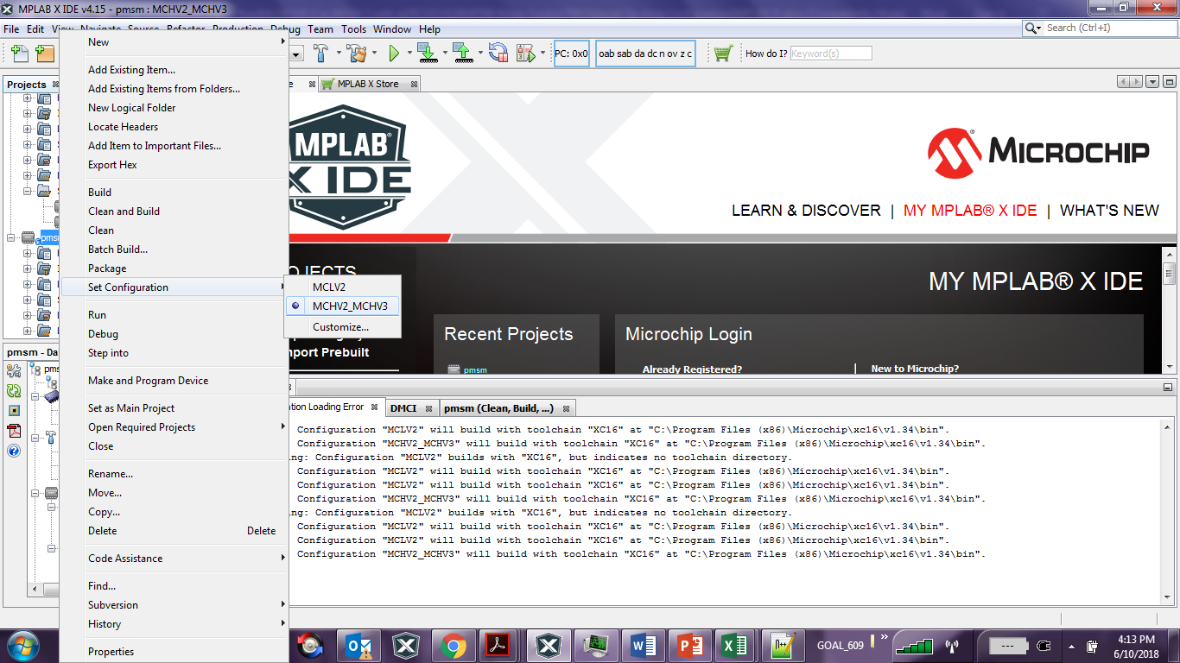

1. 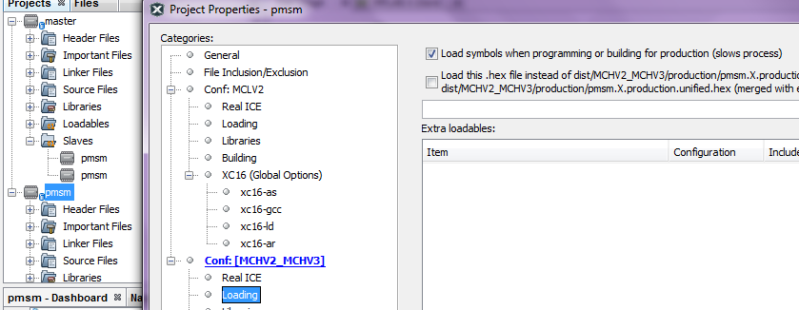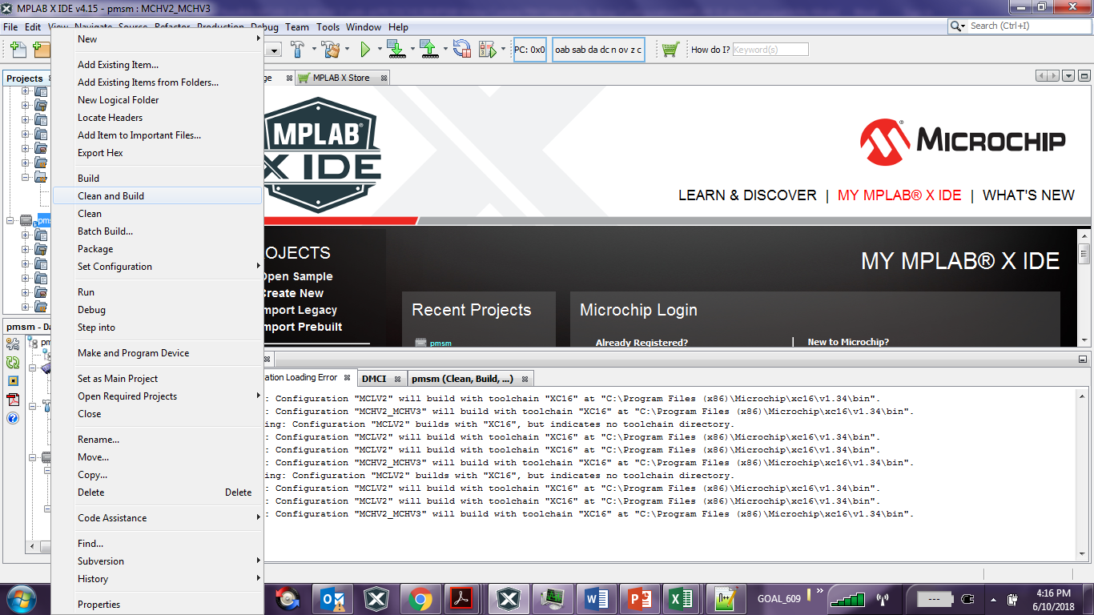Build the Slave Project *pmsm.X*. To do that right click on the Slave project *pmsm.X* and select “Clean and Build”.

**Note:**

When using RTDM with DMCI you will need to check the checkbox “Load symbols when programming or building for production (slows process)” under the “Loading” category of the Project Property dialog.

1. Open the DMCI window by selecting *Tools>Embedded>DMCI>DMCI Window.*

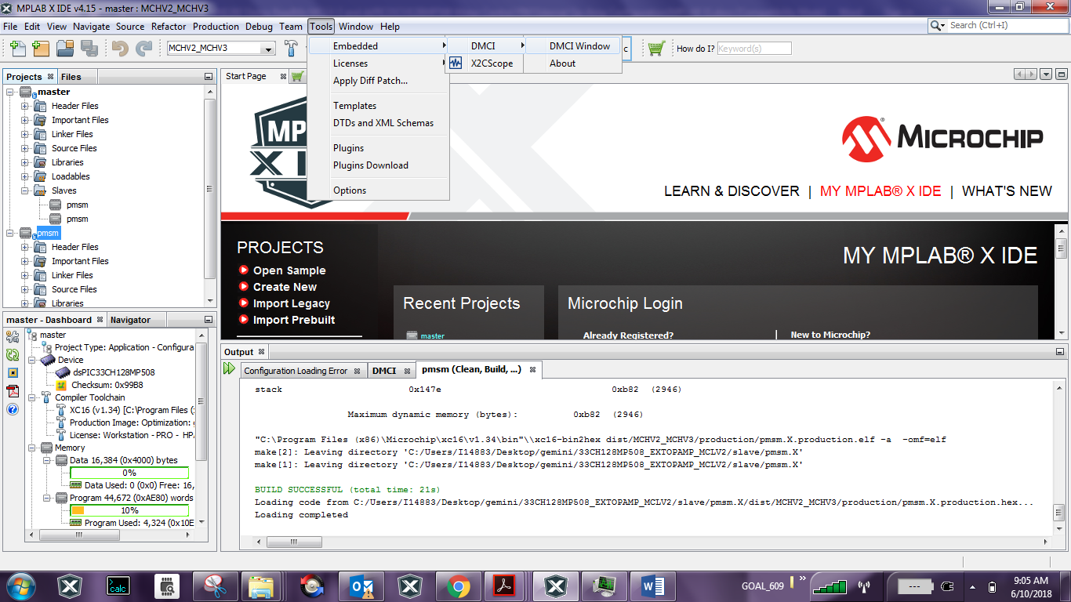

1. From the Select Project drop down menu availble in the DMCI window , select Slave Project *‘pmsm’*

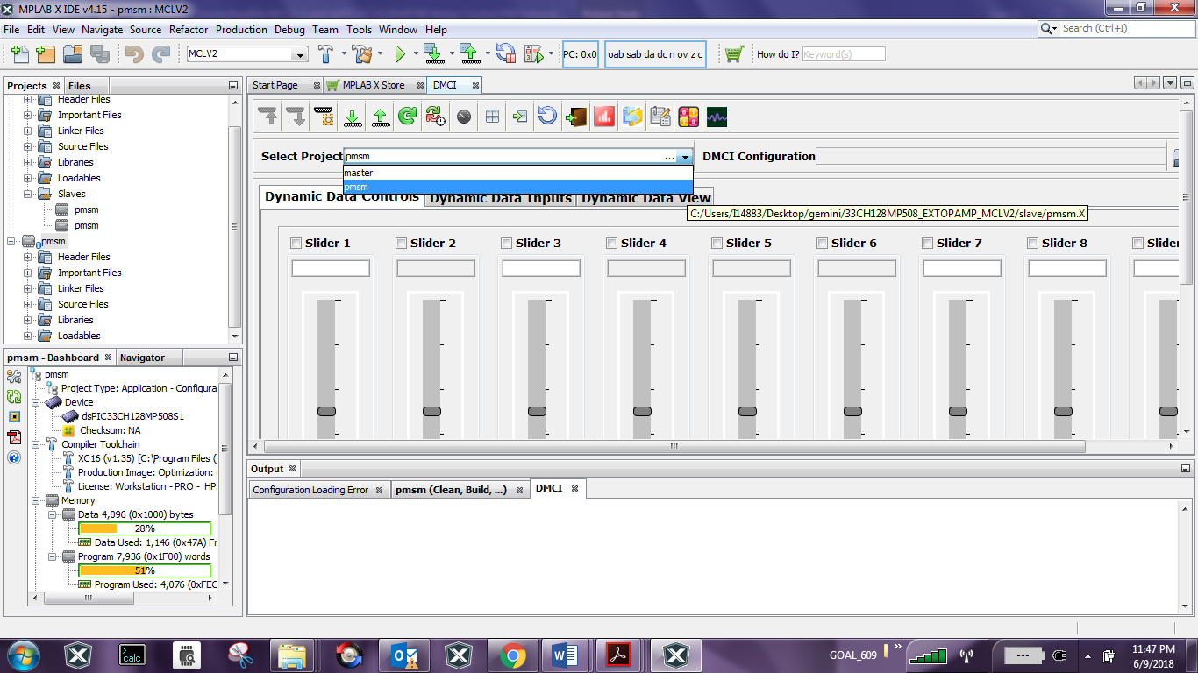

1. 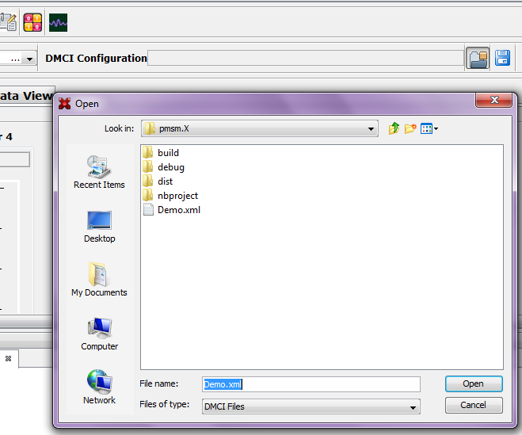Click the **Load Profile** icon, and load Demo.xml from the directory where Slave project *pmsm.X* is located. The Demo.xml file contains a previously configured profile.
2. 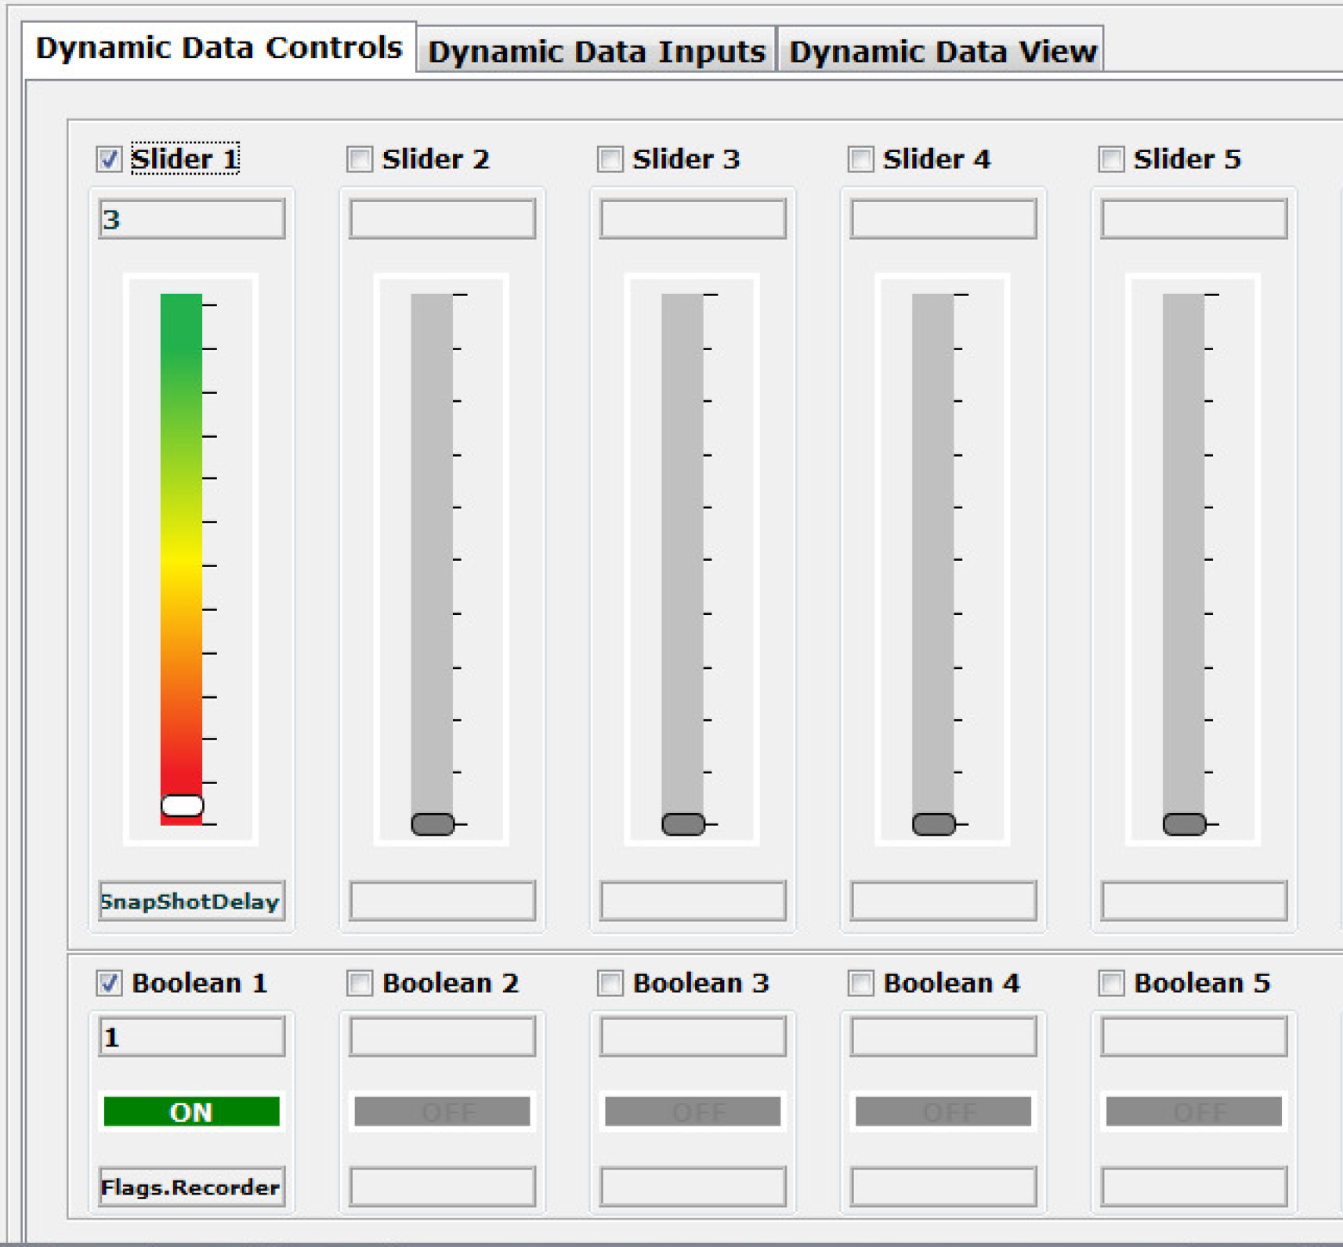The DMCI window appears as follows:

Please consult the *“Real-Time Data Monitor User’s Guide”* (DS70567) for additional settings needed for a RDTM connection.

1. 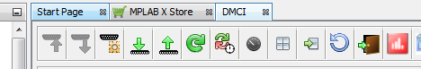Click **Serial Settings** to connect RTDM with your computer..
2. Remote Communication needs to be established, as indicated in the following figure (the communication baud rate should be set to 57600, while the COM port used depends on the your connection.
3. Once communication is detected, make sure the “Enable Communication” box is checked and click **OK**.
4. 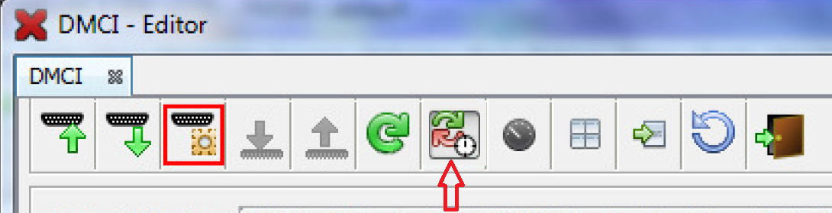To plot variables in real time, enable “Automated Event Control” by clicking **Automatic Event Execution** icon found on the toolbar.
5. 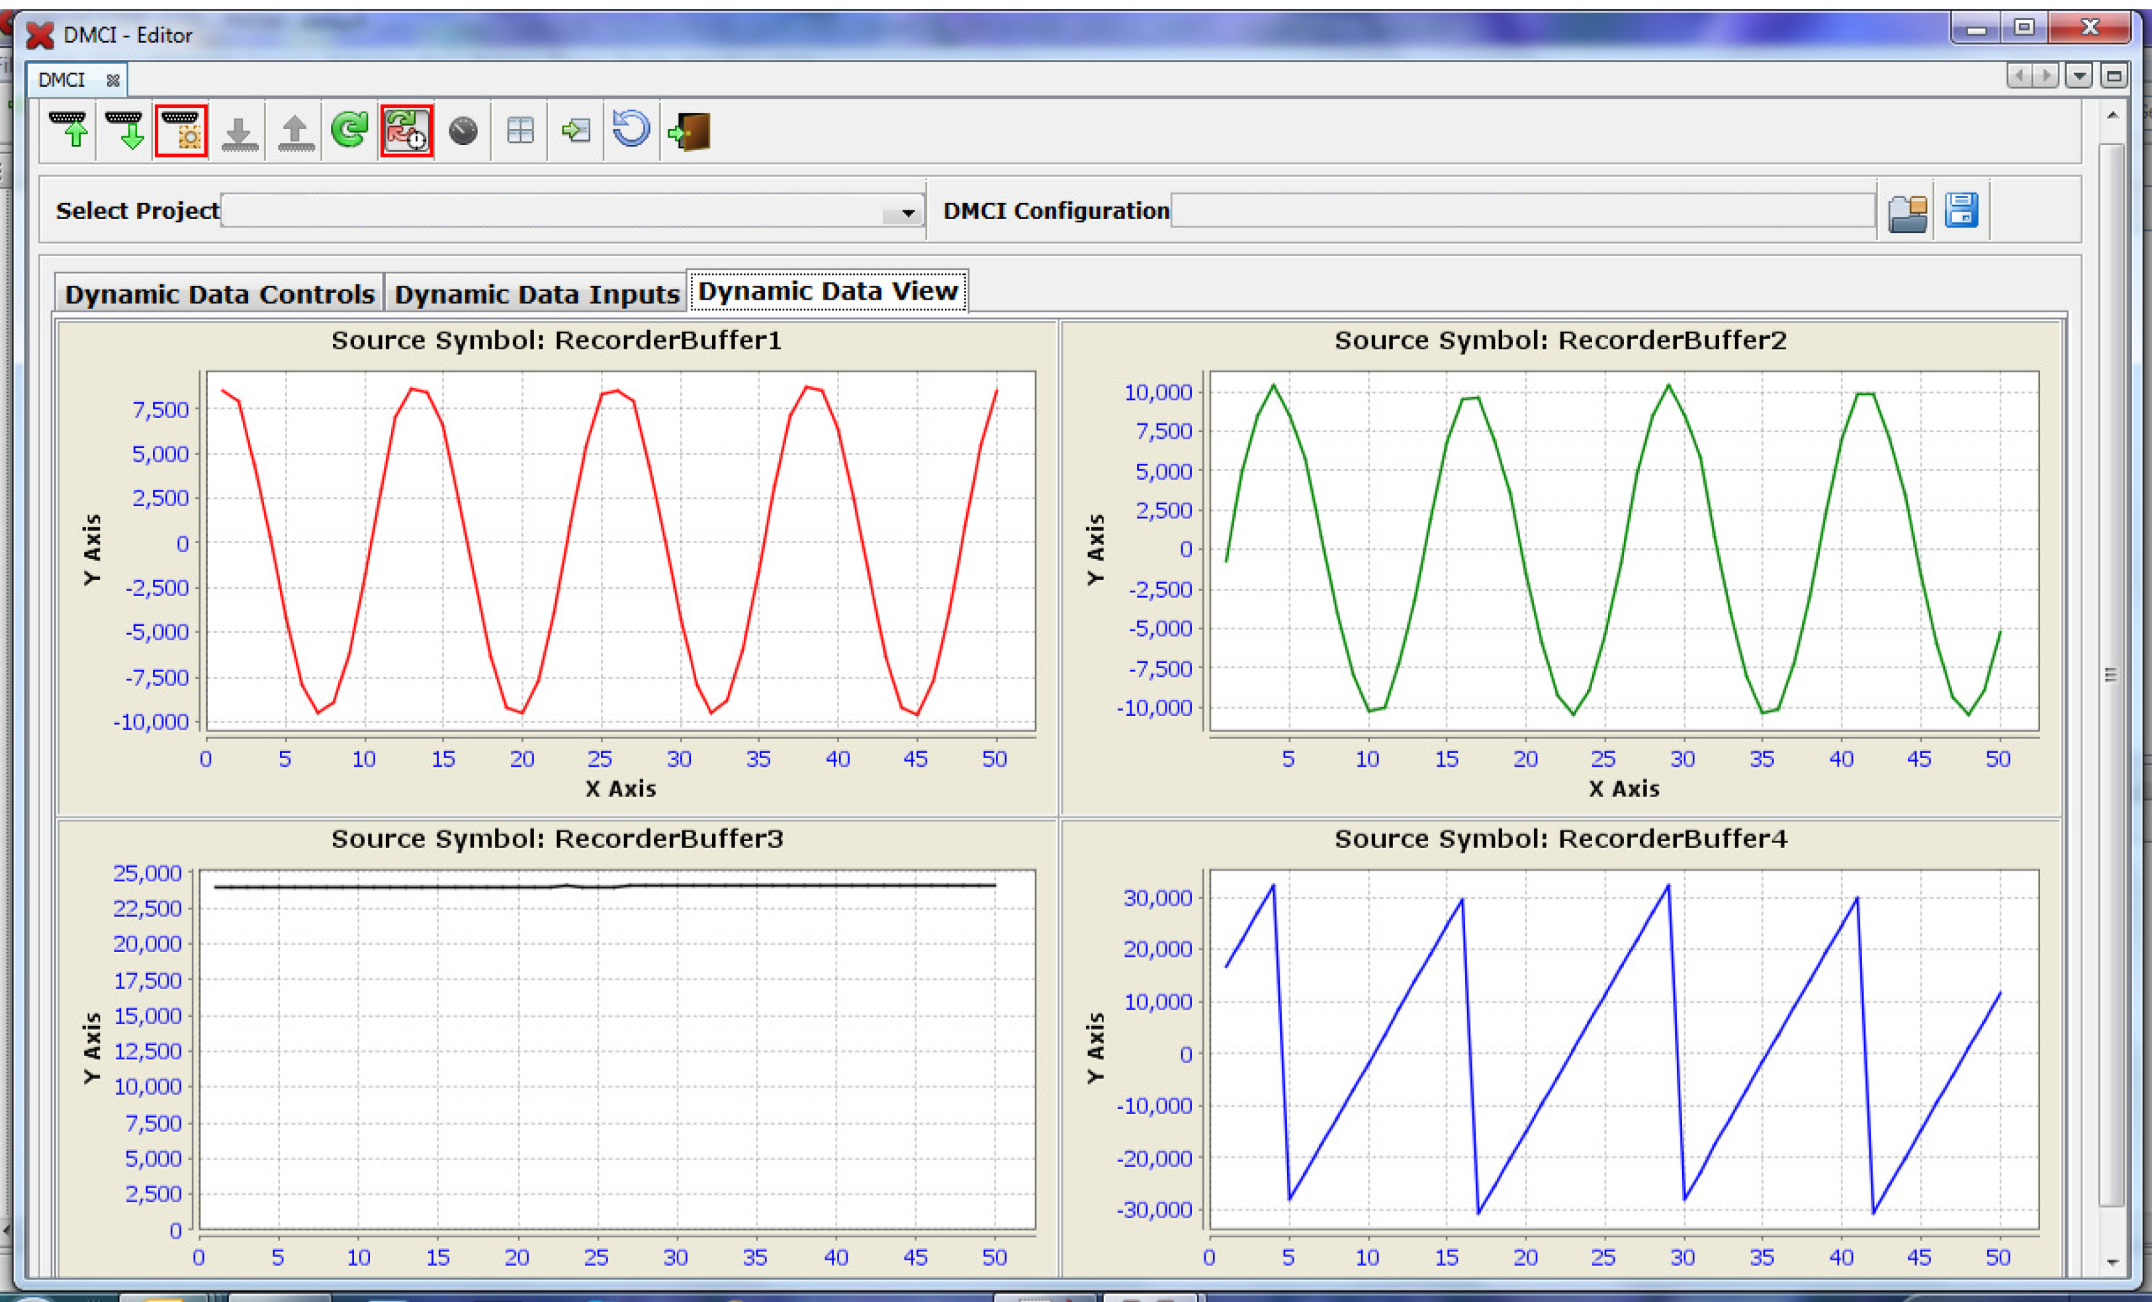The DMCI window shows variables plotted in real time, which is updated automatically.
6. 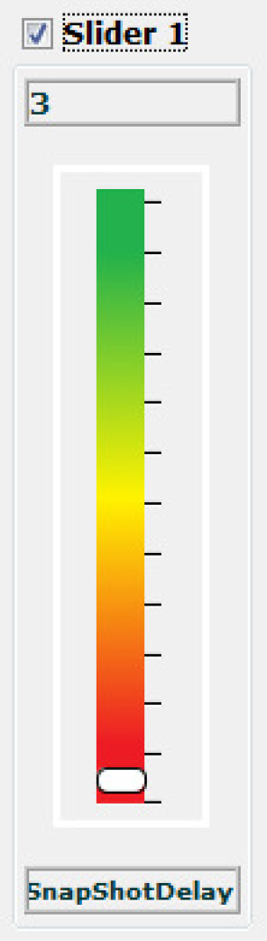To change the time window to see data over larger time span, change the value of the ‘SnapShotDelay**’**, which controls how the buffers are being filled.
7. dsPIC® DSC RESOURCE USAGE SUMMARY
   1. Device Peripherals Configured and Used in the Firmware:

The following block diagram shows the various peripherals used in the application. The dsPIC33CH512MP508 has two cores namely Master and Slave. The AN1292 motor control application firmware is implemented in the Slave core.

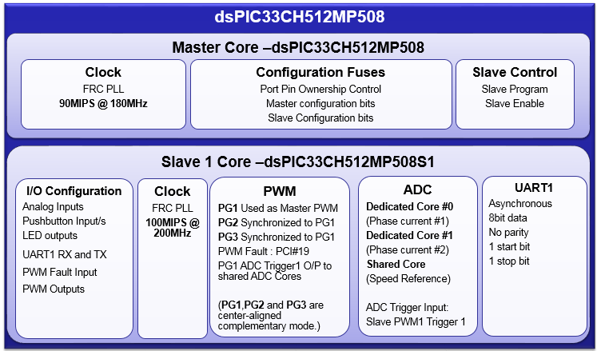

Following configurations are done in Master:

* Sets device Configuration bits applicable for the Master and the Slave. Note that the I/O port ownership between the Master and the Slave are decided by the Configuration bits.
* Configure Master Core Oscillator Subsystem to generate clocks needed for Master and its peripherals. In the firmware Master is configured to operate at 90MIPS.
* To program and enable the Slave

Following Configuration are done in Slave:

* Configure Slave Core Oscillator Subsystem to generate clocks needed for operation of the Core and its peripherals. In the firmware, Slave core is configured to operate at 100MIPS.
* Configure I/O ports such as analog inputs (motor phase currents and speed reference), Push button input (S1), LED outputs (D2 and D19), PWM Outputs Fault Input(PCI#19) and UART1 Remappable input/output (U1TX and U1RX)
* Configure PWM Generators PG1, PG2, and PG3 in Centre Aligned (PWM Mode – Complementary (Output mode) configuration as required for three phase motor control. The PWM Generators PG1, PG2, and PG3 are synchronized to each other. The PCI#19 is configured as fault source of PG1, PG2, and PG3. The PG1 ADC Trigger 1 output is enabled to trigger Slave ADC cores for sampling analog input signals at the start of PWM cycle (i.e. middle of S1PWM1H/ S1PWM2H/ S1PWM3H off time).
* Configure all Slave ADC Cores – Dedicated Core #0, Dedicated Core#1 and Shared Core. The Dedicated Core#0 is configured to sense Motor Phase Current #1. The Dedicated Core#1 is configured to sense Motor Phase Current #2. And the shared core is configured to sense speed reference set through potentiometer POT.ADC trigger source “Slave PWM1 Trigger1” is used as trigger source of all the ADC cores to allow simultaneous sampling of analog inputs. ADC interrupt _ADCAN17Interrupt () is enabled to execute motor control algorithm every PWM cycle.
* UART1 is configured for asynchronous 8bit Data transfer (with No parity ,1 Start and Stop bit). This will be used for data transfer between Host PC and Slave Core if DMCI-RTDM interface is enabled to plot data.
  1. Device Pin Mapping and Its Functionality in the Firmware:

The following table summarizes device pins configured and used in the AN1292 motor control application firmware demonstrated using the Development Board and the dsPIC33CH512MP508 Motor Control Plug-in Module in External Op-amp configuration. Refer “*dsPIC33CH512MP508 Motor Control Plug-in-Module (PIM) Information Sheet(DS50002781)”* for more information.

|  |  |  |  |  |  |
| --- | --- | --- | --- | --- | --- |
| Functional Description | PIM PIN Number | Device PIN Number | Device  Pin  Name | Signal Type | Remarks |
| **Motor Control PWMs and Fault Input** | | | | | |
| PWM1H1 | PIM:94 | 66 | S1RP58/  **S1PWM1H**/**S1RC10** | PWM  Output | Connects to Power Module U19  Input IN(UH) |
| PWM1L1 | PIM:93 | 67 | S1RP59/  **S1PWM1L**/**S1RC11** | PWM  Output | Connects to Power Module U19  Input IN(UL) |
| PWM1H2 | PIM:99 | 63 | S1RP52/  **S1PWM2H**/**S1RC4** | PWM  Output | Connects to Power Module U19  Input IN(VH) |
| PWM1L2 | PIM:98 | 65 | S1RP53/  **S1PWM2L**/**S1RC5** | PWM  Output | Connects to Power Module U19  Input IN(VL) |
| PWM1H3 | PIM:03 | 68 | S1RP68/  **S1PWM3H**/**S1RD4** | PWM  Output | Connects to Power Module U19  Input IN(WH) |
| PWM1L3 | PIM:100 | 69 | S1RP67/  **S1PWM3L**/**S1RD3** | PWM  Output | Connects to Power Module U19  Input IN(WL) |
| FAULT | PIM:18 | 49 | S1SDO1/  **S1PCI19**/  **S1RD8** | PWM  Input | Connected to  Over Current Fault Output |
| **Analog Inputs – Phase Currents, Speed Reference** | | | | | |
| POT | PIM:32/  PIM:33 | 36 | **S1AN17**/  S1PGA1P2/**S1RD11** | Analog Input | Speed Reference  Connected to Potentiometer POT |
| IA | PIM:22 | 23 | S1MCLR3/  **S1AN1**/  S1CMP2A/  S1PGA2P1/  S1PGA3P2/  **S1RA4** | Analog Input | Connected to Motor Phase Current 1 through External Op-Amp Matrix Board and Jumper J12 |
| IB | PIM:21 | 21 | **S1AN0**/  S1CMP1A/  S1PGA1P1/  **S1RA3** | Analog Input | Connected to Motor Phase Current 2 through External Op-Amp Matrix Board and Jumper J13 |
| **Miscellaneous Signals** | | | | | |
| BTN | PIM:68 | 24 | S1RE5 | Digital  Input | Connected to Push Button S1  (labeled “PUSHBUTTON” |
| Debug LED2 | PIM:60 | 59 | **S1RE11** | Digital Output | Connected to LED D19 |
| Debug LED1 | PIM:01 | 2 | **S1RE0** | Digital  Output | Connected to LED D2 |
| RX (UART) | PIM:49 | 47 | **S1RP57**/  S1ASCL1/  S1SDI1/  **S1RC9** | UART1  Input | Connected to UART-USB converter to establish serial communication interface between Host PC and Slave Core as needed by DMCI-RTDM. |
| TX (UART) | PIM:50 | 46 | **S1RP56**/  S1ASDA1/  S1SCK1/  **S1RC8** | UART1  Output | Connected to UART-USB converter to establish serial communication interface between Host PC and Slave Core as needed by DMCI-RTDM. |

1. References:

For additional information, refer following documents or links.

1. AN1292 Application Note “Sensorless Field Oriented Control (FOC) for a Permanent Magnet Synchronous Motor (PMSM) Using a PLL Estimator and Field Weakening (FW)”
2. dsPICDEM™ MCHV-2 Development Board User’s Guide(DS52074)
3. dsPICDEM™ MCHV-3 Development Board User’s Guide(DS50002505)
4. dsPIC33CH512MP508 Motor Control Plug-in-Module (PIM) Information Sheet(DS50002781)
5. dsPIC33CH512MP508 Family datasheet.
6. Family Reference manuals (FRM) of dsPIC33CH512MP508 family
7. MPLAB® X IDE User’s Guide (DS50002027) or MPLAB® X IDE help
8. Real-Time Data Monitor User’s Guide (DS70567) or [Real Time Data Monitoring Tool - RTDM](http://www.microchip.com/development-tools/reference-designs/real-time-data-monitoring-tool---rtdm)
9. [Data Monitor and Control Interface - Developer Help](http://microchipdeveloper.com/mplabx:dmci)
10. [MPLAB® X IDE installation](http://microchipdeveloper.com/mplabx:installation)
11. [MPLAB® XC16 Compiler installation](http://microchipdeveloper.com/xc16:installation)